Report: Formative 2 - Hidden Markov Models

Modeling Human Activity States Using Hidden Markov Models

Student name: Mahlet Tilahun
Github repository: https://github.com/mahlet-tilahun/hmm-activity-recognition
Video evidence: https://drive.google.com/drive/folders/1-Gn5BNXVeGn1wjRSVzAVfXMgQh5QwjZZ?usp=drive_link

- Background and motivation
In human activity recognition (HAR), the motion sensors found in a smartphone can be used to determine what the person is doing, when it is important for the information but not feasible to be continually monitored. My use case is to monitor a person's every day physical activity, but in a low-cost, privacy-respecting way, to see how much time he/she spends sedentary (not moving, standing, or walking) versus active (walking or exercising), and to alert others if he/she is a person who should be active but isn't. The accelerometer and gyroscope signals are noisy, and the actual activity is obscured by the noise; activities also appear in a predictable sequence (a person doesn't typically start jumping directly out of a stationary position). Both these concepts can be represented using a Hidden Markov Model (HMM): observations that are conditionally dependent on a hidden state, and a transition structure between the states. For this project, I recorded my own sensor values, built my own HMM from scratch using NumPy, and used it to test an HMM that I hadn't seen before.
- Data collection and pre-processing

All data were acquired by me using a smartphone and the Sensor Logger app (v1.68). I recorded the Total Acceleration (accelerometer + gravity, m/s2) and the Gyroscope (rad/s) in the form of a CSV file with a time-stamp column. In standing, walking and jumping, I placed the phone vertically against my stomach (waist level) and held it in the same position each time, while in still it was placed flat on a table with the screen up. Each clip was the same length: Start, 1 s motionless, approximately 8 s of the activity, 1 s motionless, stop. I took 13 clips for each activity for training (52 clips) and later 3 clips for each activity for testing (12 clips), in a different place from that of the training clips.

Activity | Train clips | Train data (s, after trimming) | Test clips | Test data (s, after trimming)
Standing | 13 | 111.7 | 3 | 25.3
Walking | 13 | 102.3 | 3 | 18.8
Jumping | 13 | 92.1 | 3 | 19.0
Still | 13 | 104.8 | 3 | 27.9
Table 1: Dataset

An activity clip with just one activity shows self-transitions like walking then more walking. Consequently, the transition matrix fails to learn the relationship between different activities. In order to solve this problem, a script is used to combine single activity clips into a realistic sequence of activities such as still, stand, walk, jump, walk, stand, and still. It produces a series of clips where each clip has an activity tag per row: five training clips (54–60 seconds) and two test clips (53–55 seconds) produced using the test recordings only. The sequences are created by combining single clips, and therefore, they have abrupt activity transitions.

Video evidence: The following are video clips of me collecting data for each activity.
- Standing:Standing .mp4
- Walking:Walking .mp4
- Jumping:Jumping .mp4
- Still:Still .mp4

The phone delivered 62.4 Hz (62.3-62.4 Hz, across all 64 clips) with no gap longer than one sample (16 ms), in real-world scenarios. The accelerometer and gyroscope streams have separate timestamps and can differ by one sample, so each clip is aligned on any further typical clock, 1.5 s is cut from both ends of each individual training clip (1.0 s for the shorter test clips) to remove the taps on the screen, to a significant degree. Also, the signals are linearly interpolated to one consistent 50 Hz. At 50 Hz the 25 Hz Nyquist limit is lying far above human movement (below about 10 Hz). Taken together, also 50 Hz is below the native rate, so no detail is invented.

Each logging is cut into 2 s windows (100 samples) with 50% overlap (1 s hop), in many respects. Two seconds encompass several walking stages (the primary walking frequency in my data was about 3.3 Hz) and give a 0.5 Hz FFT resolution, which is separating walking from this slower jumping rhythm (about 1.3 Hz); the overlap doubles the number of findings from short clips, on the whole. Along these dimensions, a window takes the majority label of its samples, which is giving 608 training windows (standing 192, walking 162, still 146, jumping 108) and 106 test windows.

Activity | Gravity mainly on | Std of accel. magnitude (m/s²) | Dominant frequency | Peak magnitude (m/s²)
Still | z (9.77) | 0.011 | none | ≈ 10
Standing | y (≈ 9.65) | 0.03–0.05 | none (noise) | ≈ 10
Walking | y (≈ 9.6) | 0.6–1.3 | ≈ 3.3 Hz | 12–14.5
Jumping | y (≈ 9.1) | 5.7–9.2 | ≈ 1.3 Hz | 32–44
Table 2. Signal characteristics of training clips

For each window, 24 features are extracted. Time domain (19): mean of each acceleration axis (device orientation: gravity acts on z-axis when still, on y-axis when standing); standard deviation of each acceleration and gyroscope axis (movement intensity); signal magnitude area (SMA) of acceleration and gyroscope (intensity); correlation between the acceleration axes (xy, xz, yz); and mean, standard deviation and range of the acceleration magnitude and the mean and standard deviation of the gyroscope magnitude (intensity irrespective of rotation; jumping causes very high range). Frequency domain (5), based on the FFT of the acceleration and the gyroscope magnitude (mean subtracted, Hann window): dominant frequency (walking versus jumping rhythm), spectral energy (rhythm strength) and spectral entropy of the acceleration (entropy is low for rhythmic, and high for random (still/standing) movement); dominant frequency and spectral energy of the gyroscope. These are the features used to construct the observation vector of the HMM.

As for normalization, the standard deviations, energy levels, ranges, and SMA have differences of about three orders of magnitude (0.011 in the still category and 8 in the jump category), so they are first subjected to log-transformation, after which all features undergo z-scoring using the mean and standard deviation obtained from the training windows only (same is used in testing to avoid any data leakage). This puts all the features on the same scale for the Gaussian emission model.

- HMM Setup and Implementation
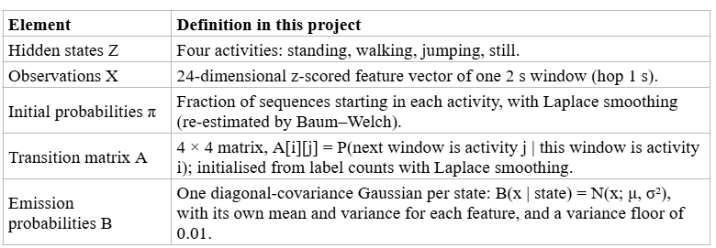
Table 3: HMM Components

The model was built from scratch with NumPy in the `GaussianHMM` class, where all computations were done in log-space to avoid numerical underflow. For activity prediction, we employed Viterbi decoding, whereas the parameters of the model were optimized by means of Baum–Welch algorithm using the forward–backward procedure. Parameters were initialized on the basis of labelled dataset using transition probabilities, activity means, and variances so that each activity could be related to some hidden state. The training process terminated when the absolute difference in average log-likelihood was less than $10^{-4}$.

- Results and interpretation

The test data consist of 12 samples described above that were recorded after training at another place. These samples have never been used for training, for calculating z-score statistics, or for setting up anything. Moreover, I walked quicker than during the training process (the standard deviation of acceleration magnitude is around 2.0 m/s² while walking and 0.9 while training, and about 11 while jumping and 8.0 while training). Thus, the test is a real change in data.

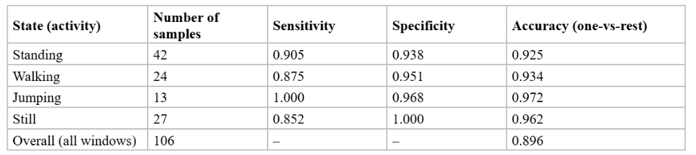
Table 4: Results on unseen data

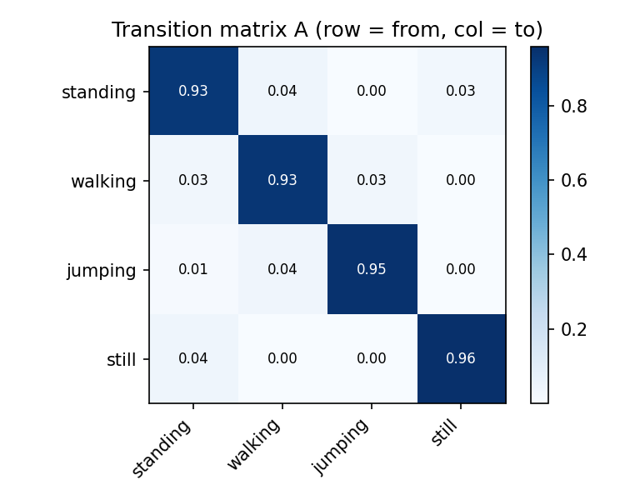 | 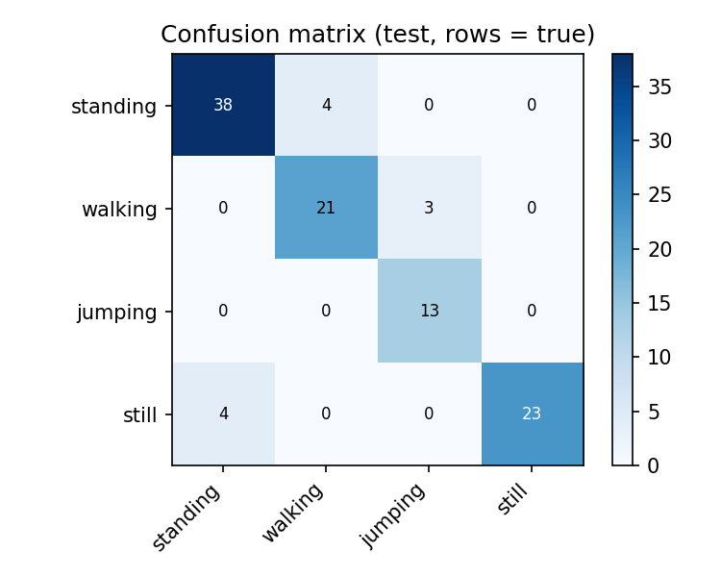
Figure 1: Learned transition matrix A and confusion matrix on the unseen test data (right; rows = true, columns = predicted).
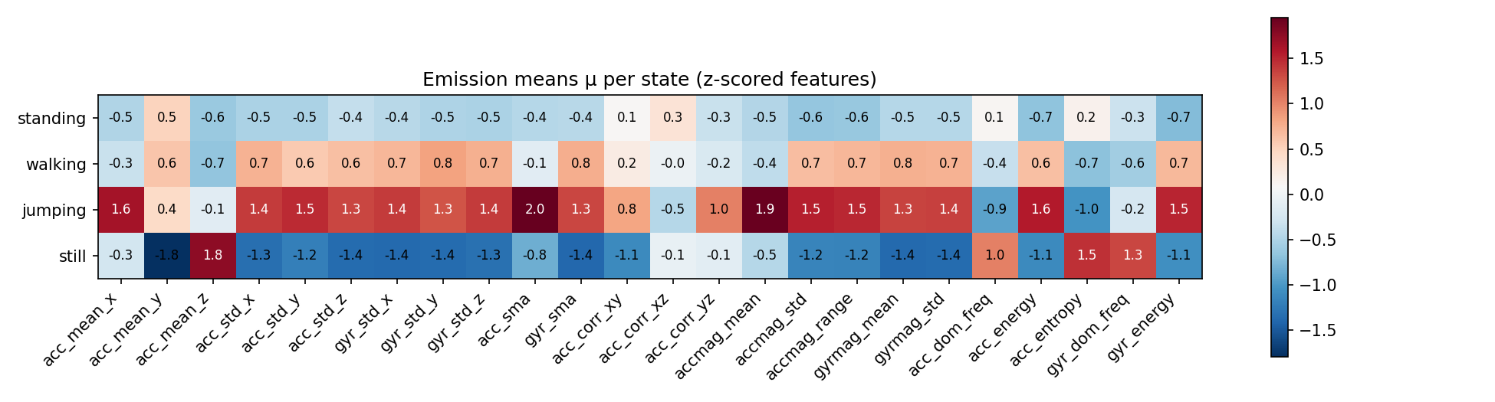
Figure 2: Emission means μ of each state for the 24 z-scored features

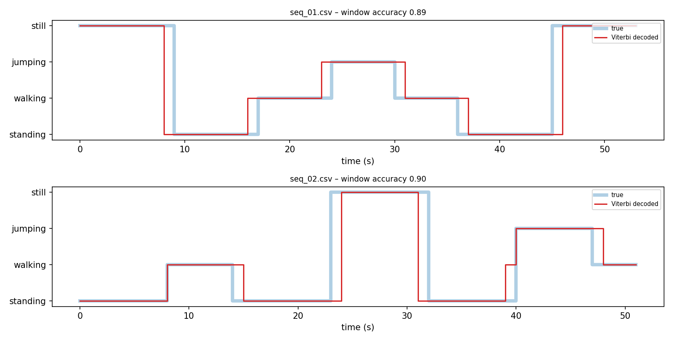

Figure 3. True activity (wide light line) and Viterbi-decoded activity (thin red line) for the two unseen test files.

Interpretation

The model's accuracy on unseen data was 0.896 (95 of 106 windows), while on the training data it was 0.965. The model generalised well with more vigorous walking and jumping. Jumping had perfect sensitivity (1.00), and still had perfect specificity. All errors were made in one window of an activity transition: standing to walking (4), still to standing (4), and walking to jumping (3). There were no errors with steady activity. This is normal as a second second in a transition can have two activities. The supervised only HMM obtained a test accuracy of 0.934, and the model without transitions obtained a test accuracy of 0.896(same as Baum–Welch). This indicates that Baum–Welch failed to do better on generalisation in this case and that temporal smoothing was not able to deal with boundary errors.

- Discussion and conclusion

It was relatively simple to classify jumping, because its effect size and signal variability are considerably greater than any other activity, and it was unambiguously clear too, with very little motion and gravity on another axis. The most difficult scenarios were those of windows during activity transitions. There is not much difference between still and standing except for the phone orientation, and therefore they would be much more difficult to distinguish if the phone was held similarly for both of them.

The learned transitions are realistic: activities are persistent, unrealistic transition like still → jumping has probability equal to zero, and adjacent activities have small non-zero probabilities. It does not represent reality completely, since I created the sequence of recordings artificially by concatenating video clips.

62.4 Hz sampling frequency was more than sufficient. Noise in the signals was negligible and mostly affected the accuracy of the dominant frequency in still and standing activity windows, but energy and entropy features take care of that.

The classifier can be improved using more people, phone orientations and days, actual transitions, windows close to the transition points, and validation data to regularize Baum-Welch algorithm.

In conclusion, the HMM trained from scratch detected the four activities on unseen data from phone sensors with good accuracy(89.6%), and its learned transitions are realistic, given the available data (one person, one phone).

